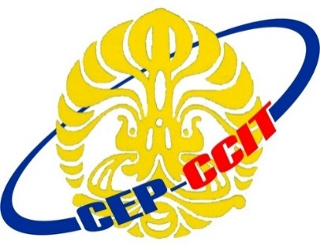

Continuning

Education

Program

Center for Computing and Information Technology

Faculty of Technic University of Indonesia

**ISAS ( Information Search and Analysis Skill)**

**“SQL Server Database”**

Name :

♦ Bella Puspieta

♦ Muhammad Hudya Ramadhana

♦ Muhammad Insan Hamzah

Group : 3

Class : 1SC2 (PNJ)

Faculty : M. Octaviano S.St